CSULB - CECS 325 System Programming
Program #5 – goldRabbits: using maps

I got a pair of rabbits for my birthday. I did some research and found out that apparently rabbits multiply like… well, Rabbits! So I have a great idea that will help me retire. I’m going to start a rabbit ranch. I need to plan for the future and determine how much land and rabbit food I will need for my rabbits.
Here are the Rabbit Rules:
- New-born rabbits take one month to mature.
- One pair of mature rabbits will have a pair of baby rabbits after one month.
- Mature rabbits will continue to produce a new pair of baby rabbits every month.
- Rabbits never die
I plan to retire in 10 years. How many rabbits will I have by then?
I did some hand calculations, and I came up with this:
At the start of month 0, I receive the baby rabbits so I have 1 pair of rabbits.
At the start of month 1, the baby rabbits are grown and the female becomes pregnant. But I still have only 1 pair of rabbits.
At the start of month 2, the first pair give birth to 1 pair of rabbits, so now I have 2 pairs of rabbits. The first pair (the adults) immediately become pregnant again.
At the start of month 3, the second pair is now mature and the first pair give birth again to 1 pair of rabbits. This gives me 3 pairs of rabbits.
At the start of month 4, the first pair gives birth to a new pair, the second pair gives birth to a new pair, and the third pair are all grown up and ready to start family life. So now I have 5 pairs of rabbits.
By now I was getting confused with counting rabbits, but I noticed a pattern. It seemed like each new month the total number of pairs of rabbits was equal to the total number from the month before plus the total number from 2 months before. That’s really cool that I can predict the number of rabbit pairs with an equation.
I’m gonna call it MGRCFRRPG or “Master Gold’s Really Cool Formula for Rapid Rabbit Population Growth”, or just GoldRabbits for short. (Apparently some Italian dude from the year 1202 named Fibonacci came up with something similar – but I think mine is much more better…)
Here’s the definition of GoldRabbits:
// this function predicts the number of rabbit pairs I will have after n months
int GoldRabbits(int n )
{
if (n == 0 || n == 1)
return 1;
else
return GoldRabbits(n-1 ) + GoldRabbits(n–2 );
}

I wanted to see how many rabbits I would have in 10 years so I wrote this little program:

#include <iostream>
#include <time.h>
#include <iomanip>
using namespace std;

int goldRabbits(int); // prototype or signature

int main()
{
int const months = 12 * 10; // this is 10 years or 120 months
int start = time(0); // number of seconds since Jan 1, 1970
for(int i=0; i<months; i++)
{
int current = time(0); // number of seconds since program started
cout << setw(5)<<current-start<<":"; // print elapsed seconds
cout << " GoldRabbits("<<setw(2)<<i<<") = ";
cout << setw(11)<< goldRabbits(i) <<endl;// the call to goldRabbits
}
}

// this is the goldRabbits function
int goldRabbits(int n)
{
if (n==0 || n==1)
return 1;
else
return goldRabbits(n-1) + goldRabbits(n-2);
}

After 17 minutes, (or 1023 seconds) here is my output:

The first column is the number of seconds that has elapsed since the program started.
The second column shows the month number (how many months into the rabbit farm).
The third column shows the numbers of rabbits I currently have on the rabbit farm.
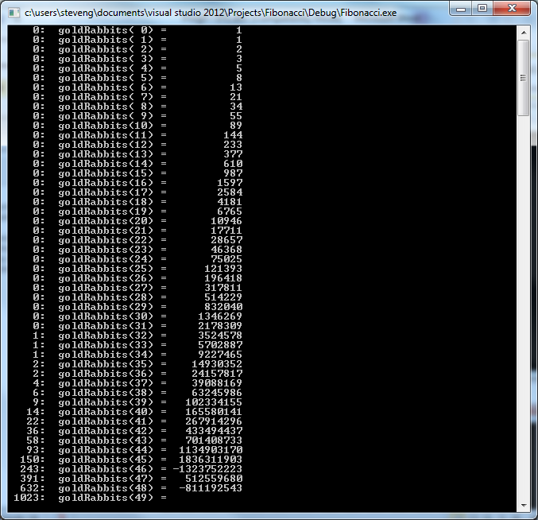

As you can see, I have a couple problems:
- For some reason, the number got real big – it was approaching 2,147,483,647 at goldRabbits(45) – (Actual value was 1,836,311,903 when it suddenly went negative at goldRabbits(46)… That’s weird. Am I right? What is going on????

- It’s taking a long, long time to calculate. At this rate, I will be retired before the calculation is complete…

Your assignment is to solve these problems for me:

- Rewrite the goldRabbits(int n) function so that it throws an exception if it detects integer overflow. The exception will throw a string that indicates the input number (n) which caused the overflow.
- Speed up the goldRabbits function so that it is very fast. You can use a static map to accomplish this.
- The fibo values are stored in a map in the goldRabbits function. If the incoming parameter is -1, then the function will print the contents of the map. Example: goldRabbits(-1) will print the map. Both <first> and <second> values will be printed – refer to the sample output below.
- One more thing: the program shown above is based on using int as the data type. However, your program will allow the user to use any valid integer type such as short, int, or long long. In order to do that, you will use the #define statement to define what INTEGER means. Here is an example:

#define INTEGER short // “INTEGER” will be replaced with “short” in the program
//#define INTEGER int // “INTEGER” will be replaced with “int” in the program
//#define INTEGER long long // “INTEGER” will be replaced with “long long” in the program

INTEGER goldRabbits(INTEGER n)
{
if (n==0 || n==1)
return 1;
else
return goldRabbits(n-1) + goldRabbits(n-2);
}

Here is the expected output of your program.

To Run:
You will run the program from the command line using the time function and the output will be sent to a log file.

Source Program: goldrabbits.cpp
Executable: goldrabbits
Log File: goldrabbits.log

The program will accept any number of command line parameters. If the parameter is a positive integer the program will print out the number and the associated Fibonacci number. If the parameter is -1, the program will print out the current fibo map. If the parameter is a string, the program will print an error. The program will continue to process all parameters without stopping.

Here is an example run and output for int data type

$ (time goldrabbits 4 -1 6 -1 3 -1 monkey 9000 horse 45 47) &> goldrabbits.log

(This is the expected log file you will submit)

fibo(4): 5
fibo(-1):
Fibo Map contents:
0:1
1:1
2:2
3:3
4:5
end of Fibo map

fibo(6): 13
fibo(-1):
Fibo Map contents:
0:1
1:1
2:2
3:3
4:5
5:8
6:13
end of Fibo map

fibo(3): 3
fibo(-1):
Fibo Map contents:
0:1
1:1
2:2
3:3
4:5
5:8
6:13
end of Fibo map

monkey is not an integer
fibo(9000): overflow error at fib(46):-1323752223
horse is not an integer
fibo(45): 1836311903
fibo(47): overflow error at fib(46):-1323752223

real 0m0.015s
user 0m0.007s
sys 0m0.000s

What to submit: (2 files)

- goldrabbits.cpp (source code file)
- goldrabbits.log (the output of the program – should look like the example above)

